First Mennonite Church • Bluffton, Ohio • Vol. 65, No. 1 • January 2018

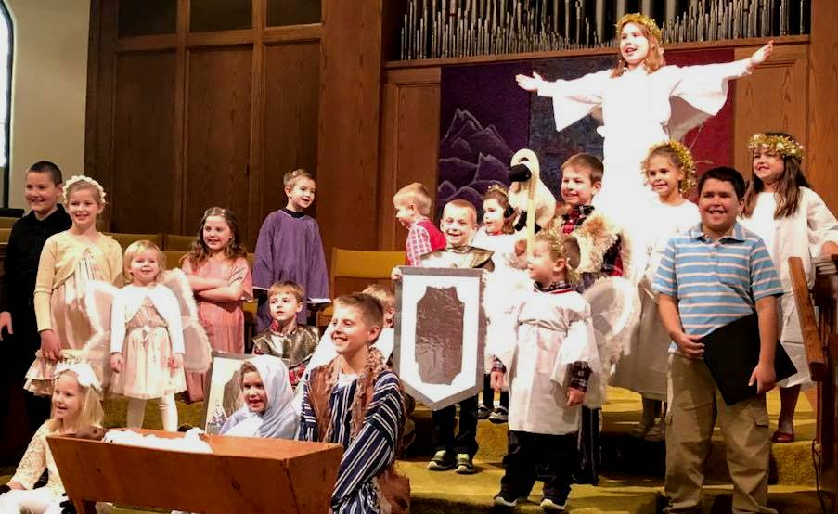
FMC’s children’s Christmas program was a success. Thanks to all of the children and adults who participated, and to the parents for their help and encouragement.

Open questions: Questions that matter

I took the motorcycle training course as a way to gain my motorcycle license endorsement a number of years ago. One of the many extremely important concepts taught in that class was that your bike naturally follows where your eyes focus. When cruising around a corner, look beyond where you are to where you want your bike to go. Look around your left shoulder and your bike turns abruptly to the left. Look down at the pavement and…you guessed it! You’ll find your bike lying there.

I believe this concept applies to lots of things in our individual lives as well as our corporate life as a community of faith. Specifically, the questions we ask will not only determine where we invest our energy today, but will shape who we become tomorrow. We will eventually find ourselves wherever we focus our attention.

With this in mind, Deacons have begun what I believe will be a generative, life-giving practice -- identifying questions that matter in our life as a congregation, and finding ways to host conversations around those questions.Our first attempt to identify a list of current questions that matter in our life together was in our Deacon meeting at the end of November. In a relatively short time, we came up with the following questions:

- How are we doing at living into the welcome/hospitality to which we’ve been called?
- How do I talk to people in the community and beyond about our welcome?
- How do we listen to the various voices in our congregation?
- How can we be gracious to those with whom we disagree while remaining honest about where we stand?
- How do we move ahead with confidence instead of acting out of fear?
- How do we convey respect and yet speak prophetically?
- What are the values that brought us to accept the Welcome Statement and how are we ready to embody them now?
- Where will the job description of Pastor of Connections take us as a congregation down the road?

Since that November meeting, we as a congregation have extended a call to Theda Good to serve as Pastor of Connections, and she has accepted. In itself, this development seems to affirm the importance of these questions and perhaps even elevates their importance.

Deacons are just beginning this practice of identifying the questions that matter among us. We look forward to the conversations that will result and to the ways God’s Spirit will move in those conversations. Gloria Hernandez Bucher, Elysia Bush, Shelby Cluts, Judy Diller, Steve Harnish, Ray Person, Adam Phillips, Tim Schumacher, Lisa Shelly are currently serving as Deacons along with Pastor Wanda. We hope that the simple act of articulating the questions here will serve as a beginning to direct our attention together and initiate conversations among us, looking ahead to our future together. -- Pastor Wanda Stopher

Dates to remember
Jan. 5-7 – SHYF, Camp Friedenswald
Jan. 8 – Mennonite Women, 7 p.m.
Jan. 10 – Pastor’s visit with MMH residents, 2:30 p.m.
Jan. 12-14 – JHYF, Camp Friedenswald
Jan. 13 – Healthy Boundaries training, CDC/OC, 9 a.m.-4 p.m., FH
Jan. 15 – Early registration deadline for Mennonite Arts Weekend
Jan. 19 – Menno-Life deadline
Jan. 20 – Theda Good and Dawn Kreider move to Bluffton
Jan. 25 – Pastor’s visit with MC residents, 2:30 p.m.
Jan. 28 – SHYF fundraiser lunch, following worship
Jan. 28 – Congregational meeting

Theda Good accepts call to join FMC as pastor of connections
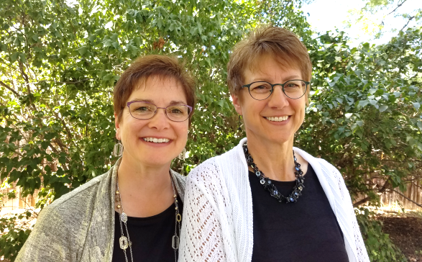
Thank you to everyone who voted in person or by absentee ballot. We had 224 total votes -- 77% voted yes, 20% voted no, and the remainder abstained.

Church council met following the vote to discern whether or not to extend a call to Theda Good. After prayerfully considering how to understand the outcome of the vote we decided to move ahead with an invitation for Theda to be our Pastor of Connections.
Theda Good and Dawn Kreider
We are thankful for the strong affirmation in this vote
for the direction of our church’s discernment process.
We respect the clear expression of dissent from that direction also present in the voting outcome. We desire for all of us to stay in fellowship with each other as we continue to give and receive counsel during this time of waiting and transition.

As Moderator, I called Theda that afternoon and shared the outcome of the vote and Council's invitation to come to First Mennonite in Bluffton as the Pastor of Connections for a three year term. She is aware of the details of the vote, and she has accepted our call. She and Dawn anticipate moving to Bluffton the week of January 20 so that she might begin her ministry among us on February 1. Pray that God's Spirit will continue to move among us as we live into this next chapter. -- Kendra Nickel

BU nutrition students to present “Healthy Eating” program to MW
“Retreat” is the theme for Mennonite Women, Monday, Jan. 8 at 7 p.m. in the fellowship hall. In her devotional, Anna Liechty Sawatzky shared a phrase veteran missionary, Jonathan Larson, said at a retreat for mission workers in southern Africa. “We are the mission field.” Anna writes, “We are the ones in need of God’s love and presence; we are the mission field. We cannot be bearers of the good news without being whole people.”

To encourage us in caring for our bodies, the Bluffton University nutrition students will share a program of “Healthy Eating” through a food demonstration. The food they prepare will become our refreshments for the evening. Elfrieda Ramseyer will share devotions and Joyce Hostetler and Heidrun Awad will be the kitchen crew.

FMC youth head to winter camps, plan soup fundraiser
January 5-7: High School Winter Retreat at Camp Friedenswald.
In one of our favorite faith development activities, we will hear from Dr. Malinda Berry, Assistant Professor of Theology and Ethics at Anabaptist Mennonite Biblical Seminary about nonviolence and peaceful communication in difficult conversations.
January 12-14: Jr. High Winter Retreat at Camp Friedenswald.
In one of our favorite faith formation activities, we will hear from Mark Rupp, Pastor of Christian Formation at Columbus Mennonite Church about the Bible and how it is still meaningful to us even when our faith journey gets messy.
Saturday, January 27: *SHYF only, fundraiser preparation, 2-4p.m., fellowship hall kitchen.

Sunday, January 28: *SHYF Only* congregational meeting soup fundraiser, 11:30 a.m. fellowship hall. One of our annual fundraisers is to provide a meal for the congregational meetings and it’s also a great way for the youth to encourage fellowship among the whole congregation.
-- Shannon Thiebeau
Mennonite Arts Weekend:
Encouraging creative expression
Consider attending the 2018 Mennonite Arts Weekend February 3-5 at Pleasant Ridge Presbyterian Church, Cincinnati. Organized and sponsored by members of Cincinnati Mennonite Fellowship, the biennial event invites artists and art enthusiasts to attend presentations, workshops, performances and worship. MAW encourages creative expression in Mennonite communities, provides exposure for artists, allows interaction and the exchange of ideas, and brings together practicing Mennonite artists and others of all traditions interested in the arts.

This year’s featured artists include Theater of the Beat with artistic director Johnny Wideman, a playwright and actor from Canada; painter-farmer Paul Buxman, San Jose, CA; Brenton Good, painter/printmaker, Mechanicsburg, PA; Karen Newe, Pasadena, CA, a professional graphic designer/freelance illustrator; Sadie Gustafson-Zook, a singer, multi-instrumentalist and songwriter; James (Jim) Heiks (brother of Bobbie Chappell), who taught choral music in the Appleton, WI, public schools for 30 years, and started a men’s singing movement in the high schools; Sarah Kathleen Johnson, the worship resources editor for the Mennonite Worship and Song Committee; Carl Bear, director of music at First United Methodist Church in South Bend, IN; Becca J.R. Lachman, poet, singer-songwriter, educator, communications officer for a library system in southeastern Ohio; Sofia Samatar, Camarillo, CA, author of “A Stranger in Olondria”, “The Winged Histories”, and “Tender”; and four-time Grammy winner Eugene Friesen, Boston, MA, cellist, composer, conductor and teacher.

The weekend begins Friday with gathering, introduction of artist-presenters and a keynote address, the opening of the Art Gallery and singing. On Saturday, there are presentations beginning at 9 and 10:30 a.m. At each time, there are several sessions to choose from. After a break for lunch (provided by MAW), there will be a hymn sing, followed by more presentations at 2 and 3:30 p.m. Dinner begins at 5:30 p.m., followed by an evening performance at 7 p.m., featuring the artist-presenters, a guest choir and/or other musical groups. The event also includes an art exhibit, as well as books, CDs, prints and artwork for sale. The weekend culminates with a Sunday morning worship service.

For more information, see https://www.mennoniteartsweekend.org/.

Janie and Neal Blough, mission partners in France, reflect on 2017

Dear friends and family,

When we look around our world at the end of this year, one quickly and sadly sees that it is a far cry from the universal image of the lion and the lamb living together in peace and harmony. Friend and colleague Alan Kreider, who died this year in May, draws attention to this yet-to-come fulfillment in a very fitting manner in his book, “The Patient Ferment of the Early Church.” He was able to complete his final work before his death, and graciously sent us a copy. His writing draws attention to the fact that first century Christians oriented their lives towards the promises of God, including those still yet to come. They practiced patience, stubbornly refusing to allow the apparent contradictions to these promises take away their hope of the “peaceable kingdom” of which the Prince of Peace was the harbinger.
Sadly – and still the case today – as years stretched into centuries, impatience drove many Christians to futile attempts of trying to take the course of history into their own hands and do things that blatantly contradicted their hope. They had forgotten that patience is not an act of “doing nothing.” Patience is not “passivity,” but rather concretely living in a way that points to the peaceable kingdom.

The painting at left includes a scene of William Penn’s effort to make peace with the original inhabitants of the North American continent. Although his attempts failed, his undertaking was not only a concrete example of orienting one’s life to a promise, but also a strong reminder that promises need to become concrete visible signs.

We have experienced many of these “signs” in a year that has been busy and rich for both of us in many ways in Mennonite Center-related activities. Opportunities for Janie to teach about worship continue to be amazingly abundant and widespread. She has also begun teaching a class in theological English at the seminary where Neal also teaches. Neal spent much of the year 2017 being involved in activities related to the commemoration of Martin Luther and the beginning of the Reformation. Many celebrations were ecumenical in nature, co-sponsored by Catholics and Protestants, and several of them made Anabaptism a part of the larger narrative of what was happening 500 years ago.

We spent the month of August in the U.S. visiting supporting congregations that we were unable to visit last summer. We enjoyed being in five different congregations and seeing many people that we only have the privilege of seeing on such occasions. The constant care for and interest in what we are doing in France that we experience during these visits is an important source of joy and encouragement for us. Thank you for your ongoing support of our ministries!

Since our return in early September, our lives have been filled with teaching, speaking, traveling and writing. We mentioned many of these activities in our update newsletter of last October. Since then, both of us have continued to teach at the seminary, and in a variety of locations in France and Switzerland, and for Neal in Guadeloupe at the end of November where he spoke once about Anabaptism and non-violence in the context of a Luther commemoration.

In February, because of ongoing contacts within the Mennonite Francophone Network, we will both be heading to Montreal to teach and speak, and then to Morocco in April. We will report on these activities in future letters.

2017 has also been a significant year for our family. We continue to be blessed by the close geographical proximity of all our children and grandchildren. Two of them moved during the year. In June, David, Julie, Anna (9) and Zoey (5), moved to the neighboring suburb of Maisons-Alfort (a 15-minute walk from where we presently live.) They now have a three-bedroom apartment that they appreciate very much. Rachel, Marc and Noah (4) moved into a house at the other end of St. Maurice in August, and now live behind the middle school that all three of our children attended. Noah began nursery school in September. Our entire family enjoyed this year’s Christmas celebration and meal in their new setting. Marc, whom we often call “Marco” to distinguish him from his brother-in-law, is now working in a customer relations service for a major corporation that has clients throughout Europe. The job necessitates being bi-lingual in French and English. He has also made use of his knowledge of Spanish as well.

With 2018 just around the corner, we want to wish you all a Happy New Year and the patience to live according to the hope brought to all of creation by the “Word made flesh.” Many situations in the world are so troubled, and never have we been so baffled by the current situation in our country of origin. Never have so many French people asked us “what is going on over there?” One description that strikes us is a seeming sense of a “cold civil war.” In like manner of the early Christians, may we persevere in long-standing patience. May we all come to realize that we share a common earth, that “greatness” is something to which all nations aspire. May they so aspire with the patience that anticipates a world of peace and justice incarnated in Emmanuel, Prince of Peace, Lord of lords and King of kings!

With best wishes and warmest greetings,
Janie & Neal Blough

Bluffton University January arts and events schedule

Jan. 10 Exhibit: “Unconfirmed,” gallery opening by John Dickinson: 2D and 3D mix, 9 a.m.-5 p.m. weekdays, 1-5 p.m. weekends through Jan. 26, Grace Albrecht Art Gallery, Sauder Visual Arts Center
Jan. 16 Forum: “JUST LOVE - Justice and Love Ignites Faith in the Beloved Community,” Forum by Rev. Daniel Hughes, 11 a.m. Yoder Recital Hall
Jan. 19 Colloquium: “Replacing GPD with Median Expected Lifetime Income,” Colloquia by Dr. Jonathan Andreas, 4 p.m. Stutzman Lecture Hall
Jan. 21 Exhibit reception: “Unconfirmed,” gallery reception by John Dickinson: 2D and 3D mix, 1-3 p.m. Grace Albrecht Art Gallery, Sauder Visual Arts Center
Jan. 23 Forum: “In Praise of Being Different: Nonconformity, Integrity and Being Christian,” Forum by Dr. Malinda Berry, 11 a.m. Yoder Recital Hall
Jan. 30 Forum: “From Charlottesville to Congo to Cleveland: The State of Nonviolence,” Keeney Peace Lecture Forum by Sarah Thompson, 11 a.m. Yoder Recital Hall

