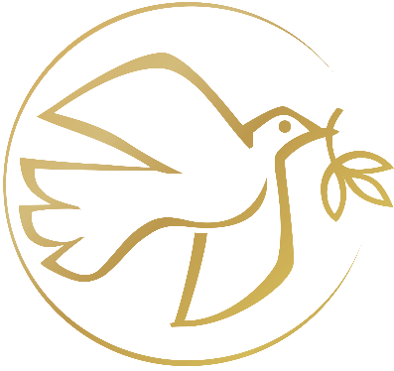

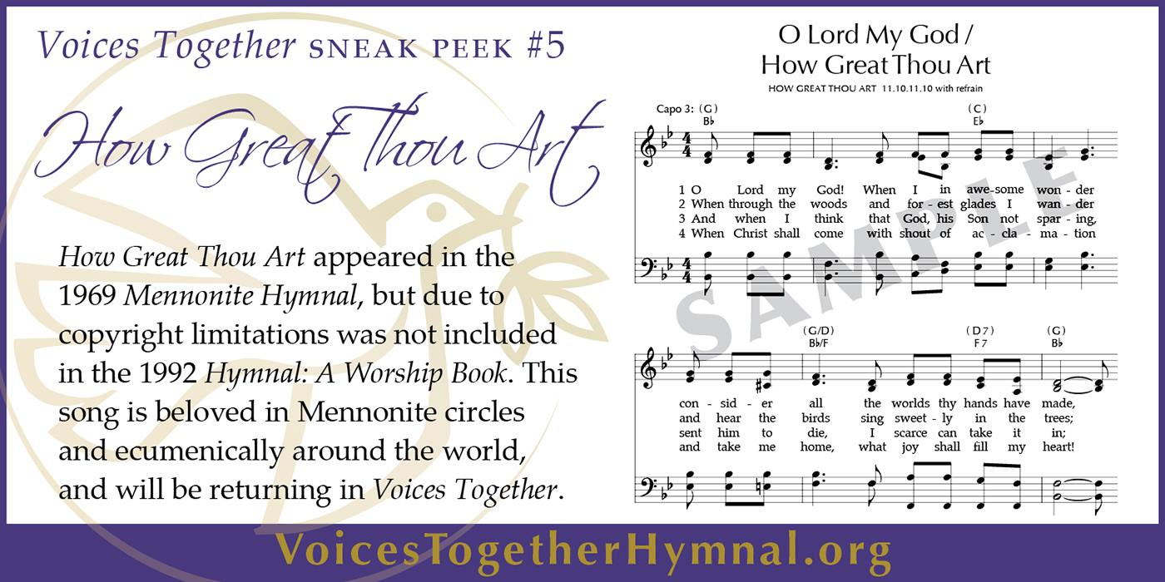
Voices Together in the midst of pandemic? Yes! Even though we are not currently gathering in person, we will focus our worship this fall on this theme, Voices Together. We will celebrate that the church consists of a wide diversity of voices. Sometimes those voices are together in agreement, and sometimes they are together in struggle and discernment. In worship we voice together our prayers and praise in word, movement, and song. In our work toward racial justice we center the voices of people who have been marginalized. We share our voices together as we nurture faith across generations. We have recognized in our video worship during COVID-19, the profound impact of the cloud of witnesses in our congregation’s life, voices together over time and history. And, of course, we anticipate the release and receipt sometime this fall of our new hymnal, Voices Together! Whether virtually or in person, we will welcome this gift as a resource to raise our voices together in singing and worship. It will then serve as a rich theme for worship at FMC during September, October, and November.

You are invited…
With the theme of Voices Together this fall and with the lack of music ensemble gatherings due to COVID-19, we are planning a time of “special music” from individuals, small groups, or families within the congregation. This time of music will use hymns presented by you, the congregation. These hymns can be from our current collection (HWB, STJ, STS) or from previous hymnals or from the new Voices Together hymnal when it arrives. We are hoping that a broad spectrum of our congregation (from old to young, from musically gifted to musically challenged, from families to individuals) will be involved. Each Sunday a hymn will be presented in whatever way you choose: talk about its history, what the text is about, what the hymn means to you, a memory about singing it, or even what singing in general means for you. Then the hymn will be presented: by solo, quartet, piano playing it, playing a video of it if we have it in our files, or Mark will figure out a way to present it. Please contact Mark Suderman if you would like to participate in this venture. We will need 10-12 individuals or groups.

9/6/2020 | Ex. 12:1-14; Ps. 119:33-40; Rom. 13:8-14; Matt. 18:15-20 | Theda Good
9/13/2020 | Ex. 14:19-31; Ps. 103:1-13; Rom. 14:1-12; Matt. 18:21-35 | Wanda Stopher
9/20/2020 | Ps. 82; Josh 7 | Alex Sider
9/27/2020 | Ex. 17:1-7; Ez. 18:1-4, 25-32; Phil. 2:1-13; Matt. 21:23-32 | Wanda Stopher
10/4/2020 | Ex. 20:1-4, 7-9, 12-20; Ps. 80:7-15; Phil. 3:4b-14; Matt. 21:33-46 | Wanda Stopher/ World Communion
10/11/2020 | Ex. 32:1-14; Ps. 23; Phil. 4:1-9; Matt. 22:1-14 | Rev. Dr. Jack Sullivan/Mission Sunday
10/18/2020 | Ex. 33:12-23; Ps. 96:1-13; I Thess. 1:1-10; Matt. 22:15-22 | Wanda Stopher
10/25/2020 | Deut. 34:1-12; Ps. 1; I Thess. 2:1-8; Matt. 22:34-46 | Gerald Mast/ Anabaptist Heritage
11/1/2020 | Rev. 7:9-17; Ps. 34:1-10, 22; I John 3:1-3; Matt. 5:1-12 | Wanda Stopher/All Saints
11/8/2020 | Josh. 24:1-3a, 14-25; Ps. 70; I Thess. 4:13-18; Matt. 25:1-13 | Wanda Stopher
11/15/2020 | Judges 4:1-7; Ps. 90:1-12; I Thess. 5:1-11; Matt. 25:14-30 | Carrie Mast
11/22/2020 | Ez. 34:11-16, 20-24; Ps. 95:1-7a; Eph. 1:15-23; Matt. 25:31-46 | Wanda Stopher

