Maundy Thursday
April 9, 2020

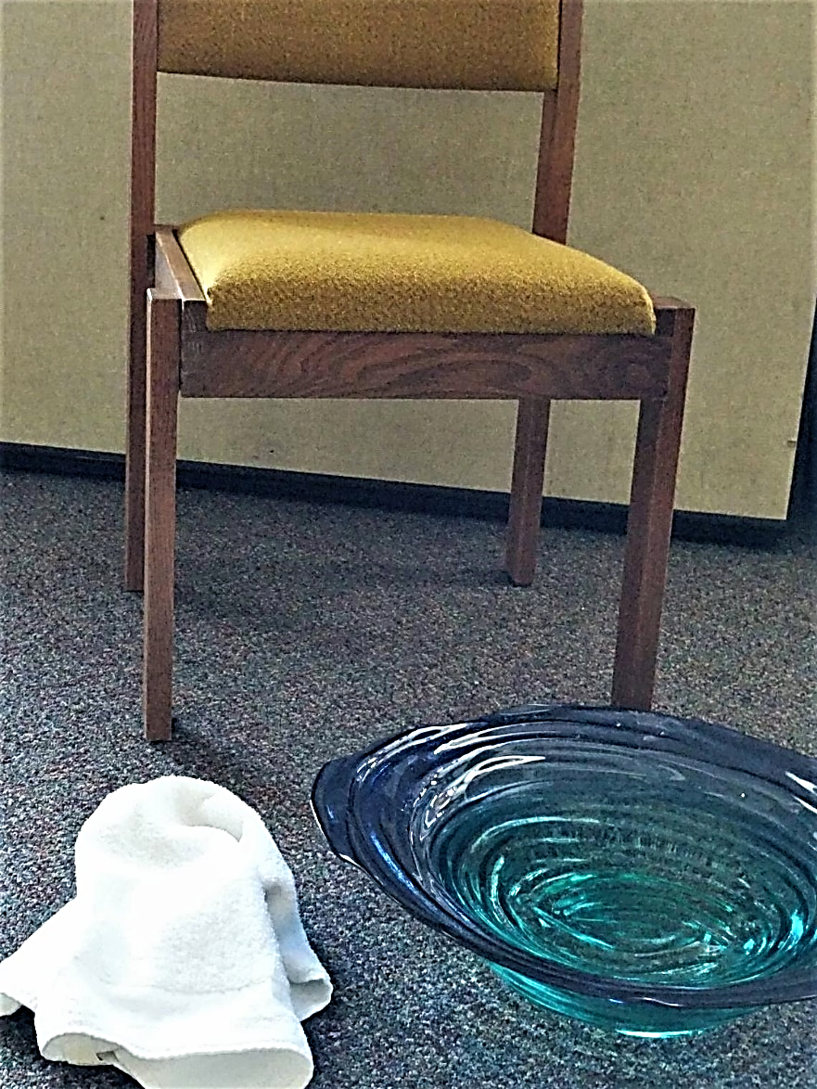

Maundy Thursday
April 9, 2020
7 p.m.
Prelude Come to Me, Come to Us Cooney & Cooney
Hartzlers – Ben, guitar; Ellie, violin; Laura, recorder
Welcome Wanda Stopher
Opening Prayer
L: Come, Lord Jesus.
You, too, were tired
when day was done;
You met your friends
at evening time.
Come, Lord Jesus.
P: Come, Lord Jesus.
L: You, too, enjoyed
when nights drew on;
You told your tales at close of day.
Come, Lord Jesus.
P: Come, Lord Jesus.
L: You kindled faith
when lamps were low;
You opened scriptures,
broke the bread,
and shed your light
as darkness fell.
Come, Lord Jesus.
All: Come, Lord Jesus.

Special Music Jesus walked this lonesome valley
Jeff and Marlyce Gundy
The Story John 13:1-17; 31b-35 Gayle Trollinger
HWB 307 Will you let me be your servant
Harnish family
Prayer
Eternal One, Spirit, Father, Son,
hear our prayers.
O, that your healing love
would fall on us, fill us and flow through us:
into our world…
into our community…
into our churches…
into our homes and families…
into our lives…
STS 60 Come to me, come to us Jackie Wyse-Rhodes
Blessing
May God bless us
in our sleep with rest,
in our dreams with vision,
in our waking with clarity,
in our souls with friendship
in our waiting with peace…
this, and every night. Amen.
Postlude Nearer to Thee Arr. Lori Line
Laura Hartzler, piano; Ben Hartzler, violin
Please leave the meeting in silence.

Opening Words from “A Wee Worship Book,” GIA Publications, pp. 58.
Blessing adapted from “A Wee Worship Book,” GIA Publications, pp. 62.

