First Mennonite Church • Bluffton, Ohio • Vol. 65, No. 2 • February 2018

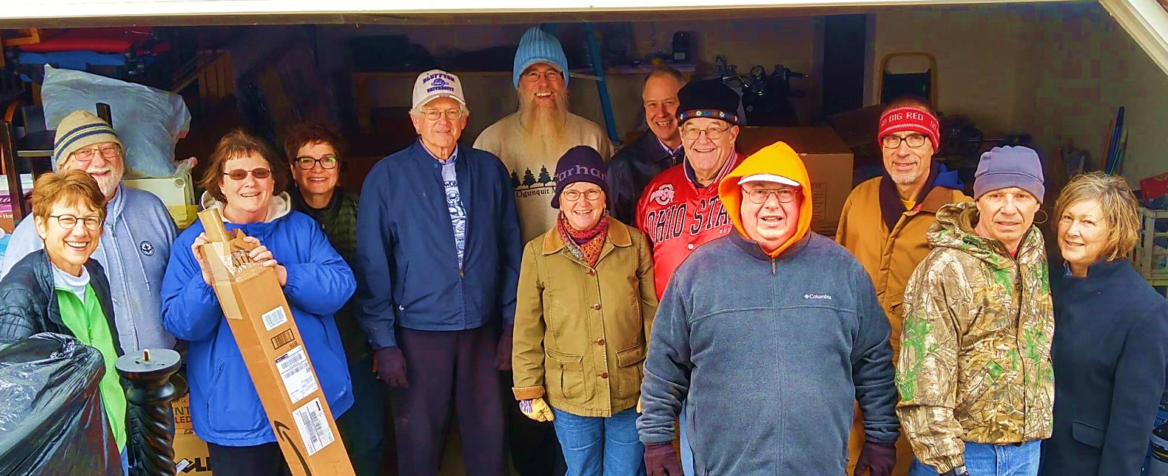
This group braved the cold to unload Theda and Dawn’s truck on January 23. Taking a break are (from left) Dawn Kreider, John Rich, Ann Kingsley, Theda Good, Ron Lora, Ray Person, Elizabeth Kelly, Doug Luginbill, Rich Bucher, Jon Diller, Glenn Buller, Bret and Wanda Stopher.

FMC enters a new chapter as transitions continue

Thresholds are powerful spaces. The range of definitions of the word includes the strip of material spanning the physical transition from one space to another. But it can also refer to a point of entry or beginning in time. And it is sometimes used to signify a particular magnitude or intensity that must be reached in order for something (a reaction, phenomenon, or result) to take place.

As a congregation that has experienced much transition over a long period of time, we stand at a threshold! With Pastor Theda’s arrival, we are entering a time of being fully staffed with settled pastoral leadership. Our transition is not yet complete; in fact it is only beginning. And yet it is clear that we are entering a new chapter in our life together. All three definitions above hold significance for us as we continue our journey as a congregation.

Just as the change from one flooring material to another is used to create a threshold that eases the transition between rooms, there are physical properties to this transition as well. We have been busily preparing the space that Pastor Theda will use as her office. Furniture has been moved, paint applied, carpet and furniture cleaned, notebooks sorted, resources and tools gathered. Physical space is no small consideration! As she moves into her office she will rearrange, decorate, and make it her own. Symbolically and physically we are making room and she will further the transition as she settles in.

Perhaps at first glance the second definition of threshold is the easiest to apply. Theda Good begins her ministry on February 1, 2018. Timewise, it’s clear and easily defined. Experientially, however, it won’t happen in a twinkling of an eye! It will take time to settle in, to orient to this new place, new congregation, new community. Obviously, the clarity of the start date doesn’t apply to the scope of the transition we are making together.

I’ll admit it is the third definition that intrigues me most, the idea that a threshold is required before something can take place. We’ve identified connections as one of the priorities for our journey together in the coming years. “We are committed to lives of mission, peace and justice, and service, reflecting Christ’s broad invitation to all people, our neighbors across the street and around the world. We live out our commitment to hospitality as we embody this priority along with others.” This priority was deemed so significant in our life together that we designate a staff person to help us and lead us! Pastor Theda has accepted the call of God and this congregation to serve as Pastor of Connections. The goal is not to fill this position! But calling and accepting can be seen as the threshold for us to live into the priority we believe to be an essential part of what it means for us to follow Jesus.

Thanks be to God, for the vision, for provision of leadership and resources, and for the joy of journeying together on this path!
-- Pastor Wanda
Dates to remember
Feb. 4 – Kim Schmidt book talk/signing, 4 p.m., FH
Feb. 8 – Red Cross Blood Drive, 1-6 p.m., FH
Feb. 11 – Theda’s installation, potluck to follow in FH
Feb. 12 – Mennonite Women, 7 p.m., FH
Feb. 16 – Julian Harnish piano recital, 7 p.m., sanctuary
Feb. 14 – Happy Valentine’s Day!
Feb. 16 – Menno-Life deadline
Feb. 18 – Hymn sing (8:30 p.m.) and pie night, 9 p.m.

Possibilities...
I have been thinking about offerings lately. Well, maybe on and off since last year at Lent when I was the worship leader, crafting words to be spoken before the congregation, preparing our hearts for the time of giving. That was before we had the option for electronic donation. At that time I was still going to the ATM to get cash out of the bank to include in my offering envelope. My check is direct deposited, so I rarely have cash. And I don't prefer writing a check. Going online to donate works perfectly for me. I was so excited when it became available last May. No more finding a time during the week to go to the bank. Now I simply go to the church website, log into my account, and push a button. Off into cyberspace the message goes until it reaches the First Mennonite electronic giving plate. I do this once or twice a month.

Electronic giving opened a new space for me. I am still supporting the church with my financial donations, but now during the worship service, I have other possibilities for what I place before the altar. During our Lent Practice meetings last year we talked a lot about creativity and what it means to offer ourselves to God. We present ourselves to the Most High when we give encouragement to others. Our gifts include what we make from wood, baked cookies or new recipes we create. Lifting our voices in adoration or writing music is another way of loving God. Some of the people in our Lent Practice created art from cloth, felt, and thread. Others created art on paper using pencils, paint, or markers.

One of the easiest ways I find myself opening to God is writing poems. I see something that inspires me in nature or some event in my life and then the words come into my mind and I write them on paper. It is like a celebration of life for me, a sensation of living and listening for the presence of God. I am quiet, I am still, and then a flurry of words appears. They insist on being heard: written, spoken, and read. Before Lent Practice, I shared these poems with a few friends and my writers group. But mostly I just collected the poems on scraps of paper on which they had been written until I typed them on my computer keyboard into a word document to be stored in a file on my hard drive. It has been this way with me for a long time. I have written poems since I was at least in the eighth grade. I wrote poems for a creative writing class at Bluffton University taught by Jeff Gundy. But when I realized I was gay and came out in 2000, something in me changed. The words of expression and authenticity began to overflow me. They express so many aspects of me...the best way I know to express myself and my thoughts. A portion of me that insists on being noticed. And most often these words express the Glory of God that I feel flowing through me.

So instead of putting envelopes, coins, paper money, or checks in the offering plate as it is passed along the row, I put in a folded piece of paper containing one or more handwritten or typed poems. Upon occasion I may offer a small piece of art. It fills me with great joy to do so. A way to share the wonder of God and nature. A way of giving that is alive to me. I think back to my days as a young single mother in 2001-2004 in this church. I did not have much in the way of finances to donate, though I gave what I could. It had crossed my mind at the time, “What if I could offer a poem instead?” I had so many. But it wasn't what was done. And I was not brave enough to just break away from tradition and the conventional way of giving. It did not seem possible. But now it does. A new way of giving has come to me. I rejoice in the possibilities...ways I can offer myself to the Creator of All...anticipating Holy Moments. -- Victoria Woods-Yee

1655 Hearing in the Silence
December 30, 2017
Victoria Woods-Yee

It is
The yearning--
Holy and
Deep...

Going
Beyond
What can
Be tolerated...

Endured
Until it
Is everything
And nothing.

There to
See, to
Feel as
It seeps

In. The
Overwhelming
Cold as
You drive

Through
The drifts
Of snow
Making a

Way where
Once there
Was none.
And now

It is all
There is...
No turning
Back. It
Is the Call.

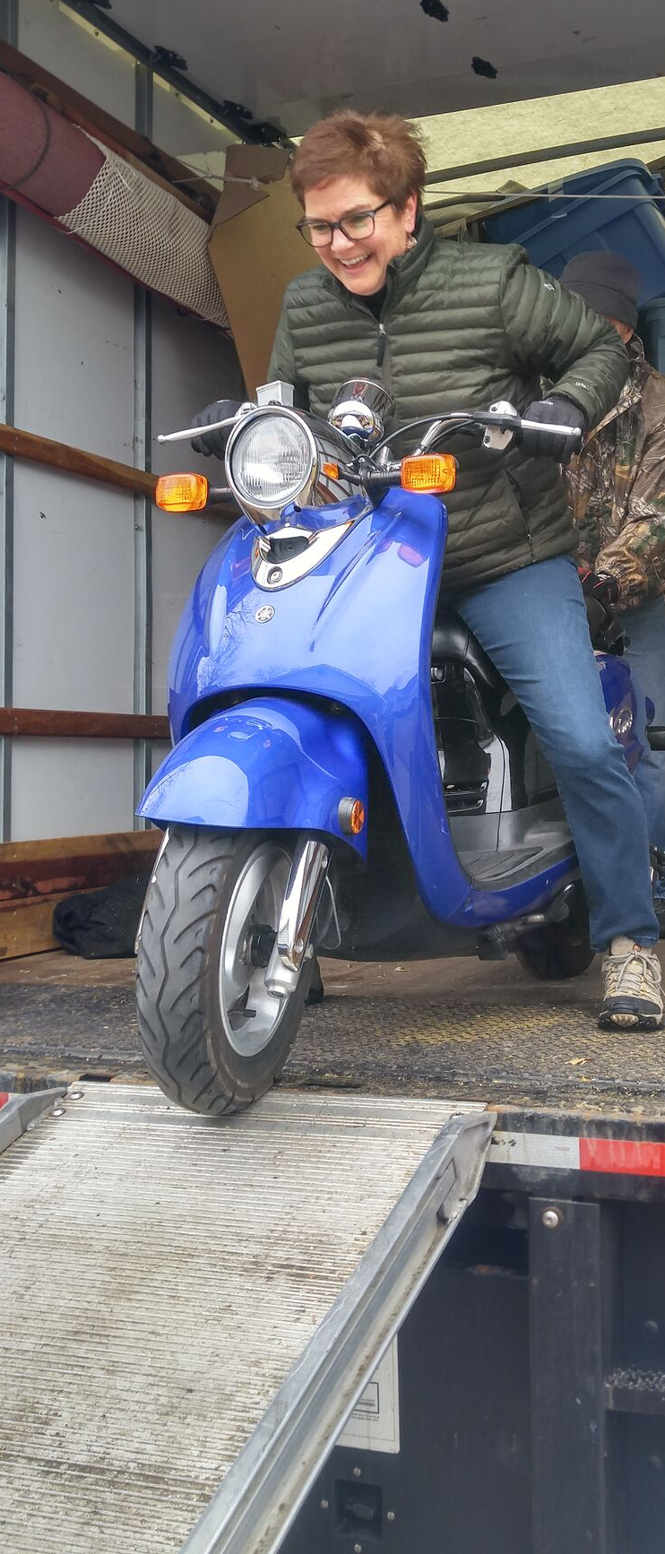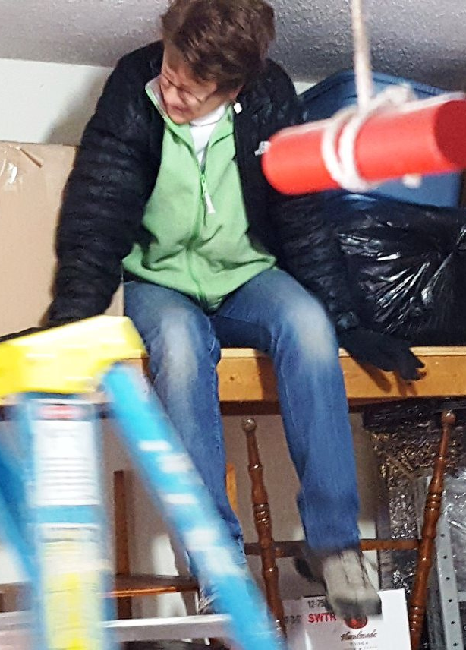
What’s a move-in day without a little fun? Despite the cold and heavy lifting, Theda Good (left) and Dawn Kreider (below) enjoyed a few lighter moments while unloading their truck.

Mennonite Women to focus on “How to say Yes”
Carrie Mast will speak on “How to say Yes” at Mennonite Women Monday, Feb. 12 at 7 p.m. in the fellowship hall.
Just after Jesus received the news of the death of his cousin, John the Baptist, he attempted to retreat to be alone, but was met by a crowd of people. Devotional writer, Anna Liechty Sawatzky, wrote, “Even as Jesus deals with his own grief, he recognizes needs in the people around him, and he understands that now is the time to engage and be with them. There are times when adding one more thing can push us too far, but we have also found it to be true that energy can multiply, and engaging with people in meaningful ways can fill a deep need.”
Gloria Bucher will lead devotions from the chapter “Engage,” in the devotional, “Live Your Call.” Refreshments will be prepared and served by Anita Lehman and Linda Miller.

Getting to know...
Rita Dietrich

Mary Pannabecker Steiner: As a child, what did you want to be when you grew up and why?
Rita Dietrich: My earliest serious memory is that I wanted to be a teacher. I'm not sure how to answer the "why.” Back then, it was an "acceptable" occupation for a woman, so it sounded like a good idea when my youth pastor suggested it. Looking back, now, I sometimes wish I had chosen a more challenging occupation. But I don't regret the choice and I believe I was pretty good at it, and still am.

MPS: Tell us about your family. Husband, children, grandchildren?
Rita: My husband of 40 years, Corwin Croy and I have one "child,” Arthur Lee Dietrich-Croy (Lee). Corwin, a retired high school administrator, is a 1969 graduate of Bluffton College and presently serves as an adjunct for the Education department at Bluffton University. Lee, a graduate of the Art Institute of Pittsburgh and Columbus College of Art and Design, presently lives in Portland OR, where he is self-employed as a product designer. Much to my dismay, there are no grandchildren.

MPS: Tell us about your professional work. Were you a teacher?
Rita: I "retired" in 2006, from Bath High School, after teaching high school math for 35 years. I presently work as an adjunct for Bluffton University's math and education departments, teaching and supervising student teachers, which I enjoy a great deal.

MPS: What church did you grow up in? What drew you to FMC?
Rita: As a young only child, my parents and I attended a Methodist church in Pittsburgh, where I grew up. As a high school student, I became quite active in the Presbyterian Church where many of my friends attended. After college and marriage, we located in Lima and became active in the United Methodist Church. I was drawn to FMC because many of our friends and acquaintances are members and because of FMC's progressive ideology and commitment to diversity and inclusion.

MPS: What is one thing you are passionate about or something you’ve accomplished that gives you much pleasure?
Rita: Teaching and a commitment to a healthy and active lifestyle.

MPS: When did you move to Bluffton and what prompted that move?
Rita: Moving to Bluffton had been a long time desire, but we could never quite work it out until 2 ½ years ago. We looked forward to living in a small university community when we could walk to most places and play an active role in the community. We are very happy with our decision.

MPS: What do you enjoy doing? Hobbies? Volunteer projects?
Rita: Teaching, attending Bluffton University activities, fitness (walking, biking, yoga, skiing, exercising), traveling to Portland to visit our son, and participating in the Mennonite Women’s quilting and sewing projects.

Youth groups retreat, relax and refresh at Camp Friedenswald
With January comes the Youth Winter Retreats at Camp Friedenswald. The high school youth travelled to camp during the first weekend of the month. Participants were Anna and Jacob Biesecker-Mast, Ana Neufeld Weaver, JC Schultze, Sophia Gott, Patrick Estell, Christopher Harnish, Jake Suter, Annalise Nisly, Tanner Pinks, Jackson Steinmetz, Sophia Smucker, Laura Strahan, Seth Andreas, and Grace Paquin. The sponsors for the weekend were Rhonda Winstead,
Walt Paquin, Bruce Steingass, and Shannon Thiebeau.

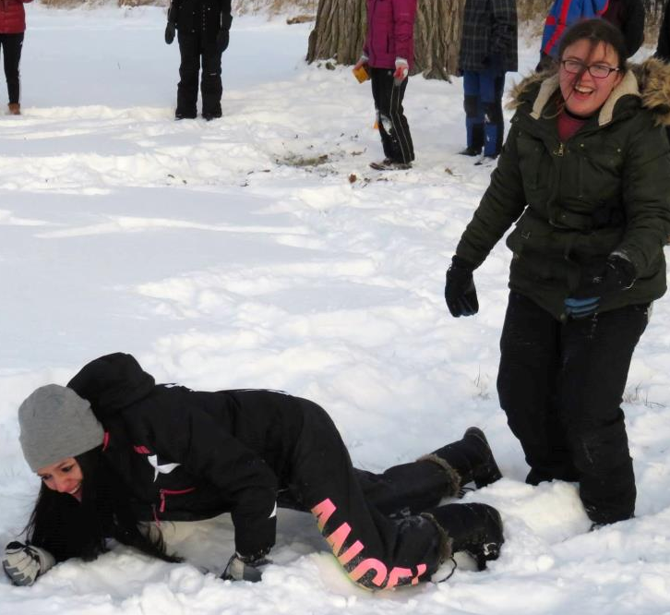
Dr. Malinda Berry, a professor of theology and ethics at AMBS was our speaker for the weekend. She taught us about nonviolent communication and how to have empathy when engaging in difficult conversations. Using the metaphor of the Jackal (representing our inner critic of others and ourselves) and the Giraffe (representing empathy for others and ourselves), we learned how to pose questions and comments in these hard conversations. When reflecting on the theme and message of the weekend, our youth noted the appreciation for the metaphors and we discussed how to use nonviolent communication in our own lives. In our group discussions, we talked about the challenges that nonviolent communication can bring, such as trying to find the right words and how to stop ourselves from assuming what the other party needs after a hurtful situation, but we also recognized the importance of good listening skills and letting ourselves be challenged by ideas and experiences that we do
not hold.

The Junior High youth traveled to camp the following weekend for their retreat. The youth that participated were Milo Combs, Ben Hartzler, John Paul Yoder, Ellie Nickel, and Theo Andreas. Sponsors for the weekend were Greg Hartzler, Ashton Cluts, and Shannon Thiebeau.
Enjoying Winter Olympics are (above from left) Laura Strahan and Sophia Gott and (below) Annalise Nisly.
Our speaker for the weekend was Mark Rupp, Pastor of Christian
Formation at Columbus Mennonite Church. Mark taught us about
biblical interpretation and how to navigate difficult passages in the
Bible and what to do when the Bible contradicts itself. We learned
that interpretation must be practiced and agreed upon in the context of community.

One of the activities that our youth found meaningful was a group activity in which we tried to interpret inkblots. Mark used that process to help us understand how biblical interpretation isn’t just a free-for-all for the individual. Every group had the same image to interpret then each group was asked to pick our top two interpretations of the inkblot. A presenter from each group then announced what their top interpretations were. Many of the groups saw similar images in the inkblot, which demonstrated the importance of community in biblical interpretation.

Both groups enjoyed the annual Winter Olympics at camp, in which all youth groups compete to win a prize by playing various winter-themed games. We were also excited to have an abundance of snow at camp this year, which led to many hours of sledding and shooting down the tube run. We love going to camp to escape from our everyday anxieties and responsibilities. For many of us, Camp Friedenswald is a sanctuary; a place to encounter God in the wilderness. It is a place to reconnect with friends and hit the “refresh button” on our spirituality. We love talking about camp and invite you to ask us about our retreat experiences! -- Shannon Thiebeau

