First Mennonite Church • Bluffton, Ohio • Vol. 67, No. 7 • September 2020
The Gifts of Bluffton
As I write this article, I only have a few more weeks left as Pastor of Connections. I know for some that title still seems a bit obscure. What is the job of the Pastor of Connections? I rather appreciated this title and saw four main areas in which my job description gave me direction for how I spent my time. Connecting with folks in the congregation was an obvious area - pastoral care being a big piece of this including working with families at the time of death and helping them to create a memorial service that would honor the life of their family member. A second area of connection was with Central District Conference and Mennonite Church USA. A third area of connection was with Bluffton University. A fourth major area was connecting with the community. Keep reading to learn more about what I will miss from each of these areas, as well as a few additions from Dawn.
First Mennonite Church
- Youth Sundays – all of them! A special shout out to the annual sharing by the seniors, reflecting what it meant to them to grow up at FMC.
- The joy and energy at the youth fundraiser events.
- Each and every one of the choirs – cherubs, jubilate, youth, and adult. And, not forgetting the bell choirs, both youth and adults.
- Extraordinarily talented musical congregation - I have sung so many songs here that I did not know.
- Dawn will miss driving the MMH bus to transport folks to Sunday school and church.
- Dawn will also miss playing chess with Brandon Rhodes before church.
- We appreciate the many plants we were given by LuAnn Stuckey, Betty Shelly, Fran Core, Linda Miller, and Wanda Stopher.
- The many puzzles we shared with and borrowed from Fran Core, Ruth Early, Joanne Niswander, and Carolyn Rich.
- Working with the planning team for the one-day event we called Living Faithfully, Dying Well
- Doing the work of social justice, living the challenge of Jesus’ life example and teachings. This specifically included:
  - The trip to the US/Mexico border with nine others from FMC. This is definitely one of the highlights.
  - Working with Mission, Peace and Service.
  - Participating in the silent walk to honor George Floyd’s life and the many other Black lives that have been lost due to racial profiling.
Central District Conference/Mennonite Church USA
- I greatly valued my connections with other pastors within Central District Conference, as well as the broader Mennonite denomination. Some of these folks are my dearest friends.
- The work with Inclusive Pastors Leadership team to challenge homophobic practices and language in the denomination. Working to support a resolution that will be brought to the delegates at the next convention in Cincinnati, July 2021.
Thankfully, these connections and this work is not something I need to leave behind. I will continue building on these relationships and doing the work to build a more inclusive Mennonite denomination.
Bluffton University
- Lighting of the Houshower House at Christmas
- Annual singing of the Messiah
- Musicals, plays, concerts
- Connecting with the students in the Brave Space group and attending their meetings
  - Helping to plan the Trans Day of Remembrance service in November
- Attending Forums, Colloquiums, and chapel services
- Athletic events
- The Nature Preserve – a beautiful oasis of forest and wildlife. A serene place for a walk, for exercise or catch up with friends
- The annual Harvest Dinner
- The treasure of the Lion and Lamb Center, offering resources on peace building
Village of Bluffton
- Affordable movies at the Shannon Theater including recent releases
- Blaze of Lights parade
- Being able to leave the car running on a cold winter morning while shopping at Community Markets (Not that I ever did it, just loved the idea that others felt safe enough in this town to do it. Not commenting on the environmental factor of this practice)
- Bluffton Family Recreation Center became a place of creating yet another community around pickleball. The nurturing and support given to whoever showed up to play hard or simply to learn for the first time
  - This includes regular connections with FMC folks like Rich Bucher, Glenn Buller, Jerry Weaver, Brent Schroeder, Ron and Linda Headings, and others on occasion.
  - Dawn and I truly value the connections made with others from the community. Most recently it was the regular playing with Tom, Larry, Christian, Dylan, Bill and Sue.
- Tuesday food trucks at The Centre
- Soup cook-off at Maple Crest
- National Night Out - fireworks in August, a celebration of this community
- My connections with the other BAMA pastors (Bluffton Area Ministerial Association)
  - Doing Ashes-2-Go at minus 12 degrees in February
  - Chili cook-off
  - Other events we organized and worked at together to care for this village
- Downtown shopping
  - Et Cetera Shop (a place to get rid of clothes that no longer brought us joy)
  - Shirley’s Popcorn
  - Ten Thousand Villages
  - Twisted Whisk
  - Roots
  - The Dough Hook, especially their ham loaf
  - The Dari Freeze – we, too, became acquainted with calling it the Whippy Dip!
- Really appreciated the growing number of bike paths around the village
- Our weekly walks down Snider Road – we called it the dead-end walk for short. We both knew it was a three mile walk from our front door and back
- No traffic jams in this small town AND we could get most anywhere in 5 minutes
- Appreciated being able to use our scooter around town with an increase in feeling safe by 100% compared to a big city
- Bluffton High School seniors painting on College Avenue
- Seeing regular sightings of deer, an animal that bridges us with those we love and lost
- Watching the cycles of the Riley Creek and the Little Riley through the seasons of abundance and drought
If you have been wondering what warm memories we will be taking with us, I hope I have answered that question. Not everything mentioned here was part of my job. It became a rather eclectic list. I am glad we answered the invitation to come here for this season of our lives. I trust it has been mutually beneficial. May the peace of Christ encircle each of us even as we part ways.
~ Theda Good, Pastor of Connections
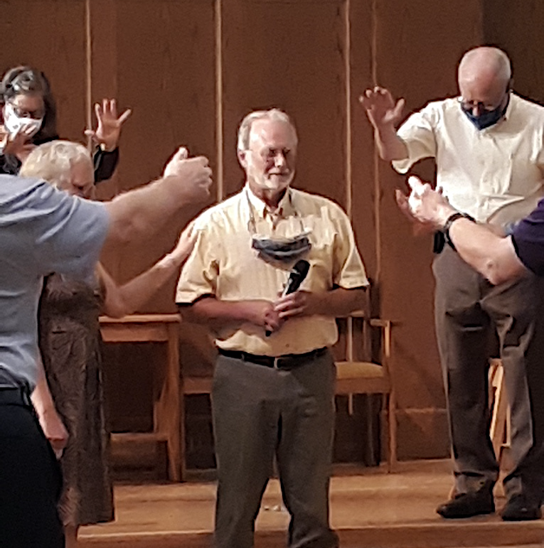
Jeff Boehr licensed in August 12 service
Jeff Boehr was licensed for specific ministry as interim pastor during a service August 12 at First Mennonite Church. Doug Luginbill, Central District Conference minister, led the service.
According to Doug, “It was a joyous event even as COVID-19 has forced us to amend our typical practices.”
Jeff’s wife, Beth, and his father, Dick, participated in the service, as did First Mennonite pastors Wanda Stopher and Theda Good, and the FMC deacons.

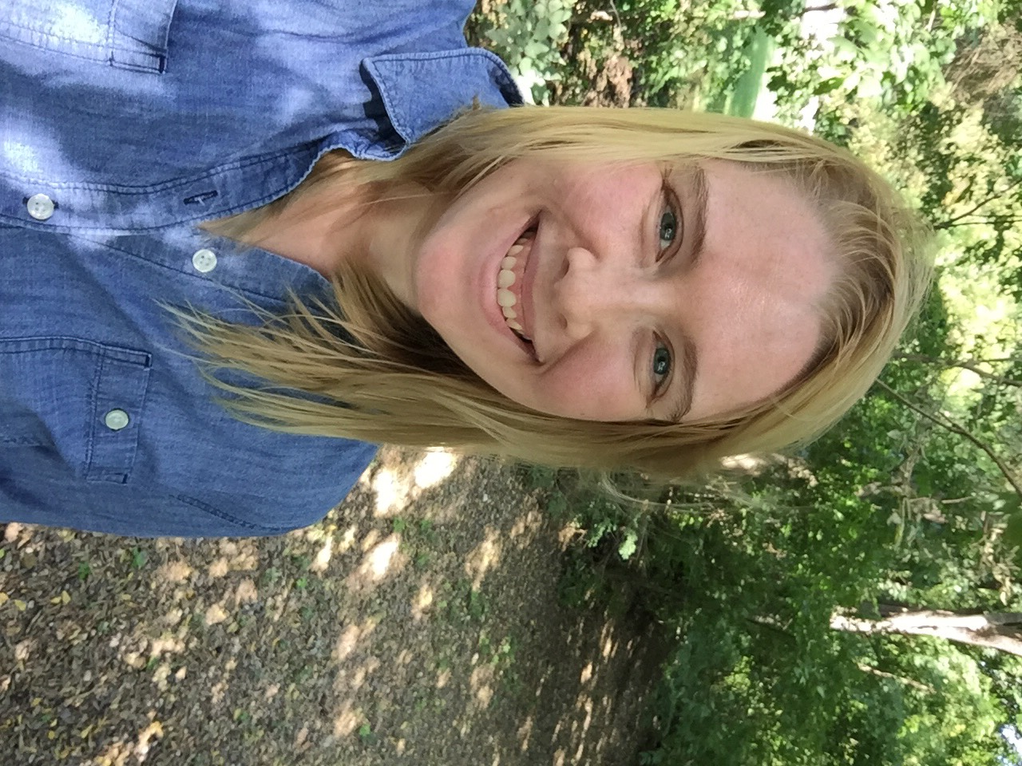Hello First Mennonite family!
I am starting my third and final year of seminary at the Methodist Theological School in Ohio in Delaware, Ohio. This October, I anticipate beginning my clinical pastoral education with OhioHealth in Columbus, which is a hospital chaplaincy internship. I hope to use this experience, along with my Master of Divinity degree, to pursue chaplaincy and ministry licensing through MCUSA as a vocational career.
Earlier this month, I moved from my family’s place in St. Marys to MTSO’s campus to pursue some student leadership opportunities, begin my internship, and get involved in my seminary’s community. Some of you may know that there are many Bluffton and other Mennonite connections with MTSO and the Columbus area and I am excited to get connected with Columbus Mennonite, where some of my professors and classmates attend (such as Chaska and Phil Yoder, who are relatives of Janet Yoder.)
Like many other schools across the country, we are navigating how to continue to have classes that are both equitable and safe for everyone. Some of us will be in person and others will use Zoom to meet for class, but we would all appreciate prayers not only for MTSO, but for schools all over the country.
As scary and uncertain as this new phase of life may be, I am excited to be pursuing this journey and thankful for the support that my friends, family, and FMC family has given me over the years. I pray for peace and safety for First Mennonite and look forward to the day when I can visit again! ~ Shannon Thiebeau
Getting to know John Rich
By Ruth Naylor
John Rich was born at home in Archbold on July 29, 1940 and was named for his grandfather Rich. John’s father and uncle owned the Rich Ford Dealership in Archbold. John and his older sister attended the public schools.
At Albion College in Albion, MI, John majored in math and physics. Then he earned his electrical engineering degree at the University of Michigan. The Vietnam War was raging and John was registered as a conscientious objector. When his draft number came up, he was told to report for a physical. John explained, “It was scheduled for the same day as three of my final university exams. My enterprising father knew someone on the draft board, and he explained that his son, who was studying to be an engineer, really needed to take those exams.” John’s name was scratched from the list and John was not contacted again.
After graduation, he stayed at the university and enrolled in the masters in business administration program, but after one semester he decided it was not for him. An opportunity to teach math and physics at Bluffton College became available; in 1964 he “left the beautiful state of Michigan and moved to Bluffton, OH.”
BC is where he met Sarah Hunsberger who was Dean of Women. John chuckled, saying, “Our relationship became a hot topic on campus.” Rightly so, perhaps, because it developed into a good marriage.
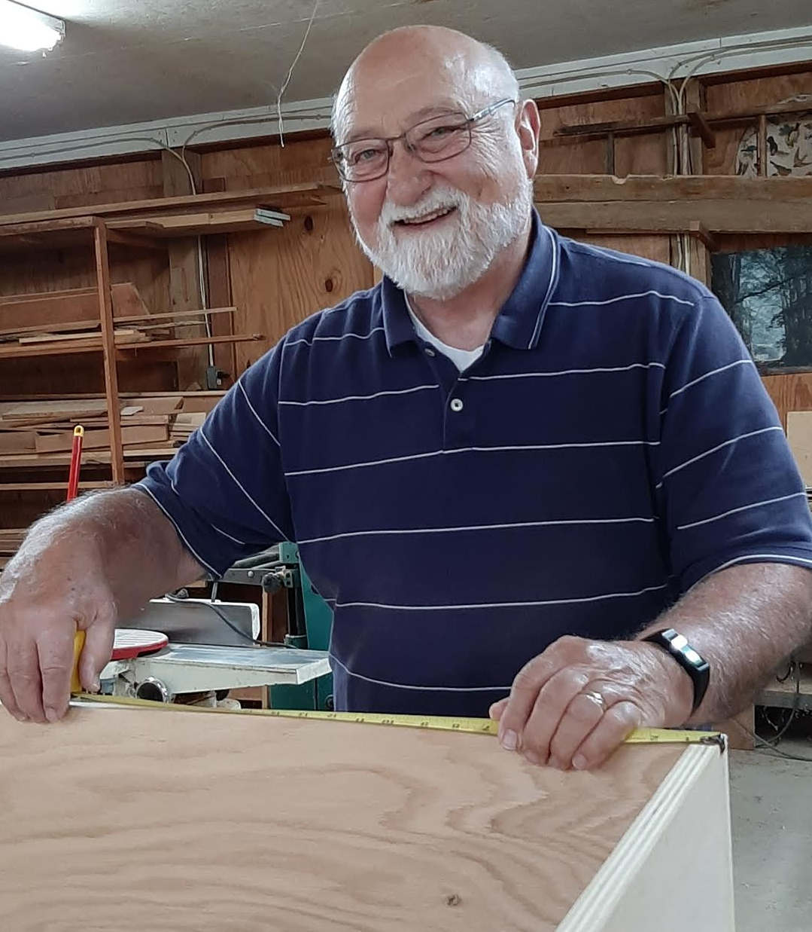
For two years, John “managed to survive while carrying a heavy teaching load and running BC’s brand-new computer center that was servicing not just students but the whole college.” Understandable burn-out! He and Sarah, knowing they needed a change, explored voluntary service with MCC and ended up at a self-help shop in Kentucky. After that, they returned to a house on one of his grandfather’s three farms. John joined his father at the Ford dealership until he found his niche again in teaching.
John’s teaching career in math, physics, and engineering included Bluffton College, Northwest Technical College, and the University of Toledo.
Sarah and John had two daughters, Amy and Kirsten. Then sadly, after 31 years of marriage, Sarah died of metastasized ovarian cancer. It happened that Sarah’s memorial service was on the very same day as the one for Carolyn’s husband, Joe Urich.
A few years passed. Carolyn was working in the registrar’s office at BC with Linda Suter who was certain that John and Carolyn would be a good match. When Linda and Bob finally got them together for dinner, the two discovered that they had a lot in common. They both had roots in Alsace Lorraine, both of their fathers were businessmen, both grew up in the Evangelical Mennonite Church, and while they changed Mennonite affiliations, church was important to them. They loved music and enjoyed making things. Both had loyal connections to Bluffton College.
They each had friends and family ties in a variety of places so after courtship turned to marriage, John sold his inherited farm in Archbold, Carolyn sold her house on Jackson Street, and they chose a lovely home in Bluffton’s Riverbend Addition where they could entertain.
In order to accommodate the many who wanted to attend their wedding, they had four ceremonies. The first was with John’s children at the home of Ann Nofziger, a long-time friend in Cincinnati. John’s future son-in-law married them. The next two ceremonies consisted of repeating their vows at Zion Mennonite in Archbold and First Mennonite in Bluffton after their worship services; these events were followed by receptions. The fourth and final repetition of vows happened in the Colorado mountains with Carolyn’s children.
John and Carolyn now enjoy traveling to visit their children and grandchildren. One of John’s daughters lives in Evansville, IN, and the other (who has given John three grandchildren) lives in Nuremburg, Germany. Carolyn’s children still live in Colorado. Summers are spent at John’s cabin in Ponshewaing, MI, near Petoskey.
John’s faith is clearly expressed in service. Important among many beneficiaries of his time have been and are a soup kitchen in Toledo, Our Daily Bread in Lima, and the Sunshine Home in Maumee. He has written grants and helped raise money for others as well. At FMC he has served multiple terms with the trustees, with Mission Peace and Service, on church council, and for many years as the FMC representative for the Black Swamp Benefit.
Asked what he believes is the hardest part of growing older, John replied, “Realizing that you’re getting older.” His hobbies are baking bread, woodworking, and fishing.
His advice for others? “Try to set a good example for those who follow.”

How we spent the summer of 2020…
Many of our usual summer activities were put on hold as we struggled to find ways to keep busy while staying at a distance from others. Most vacations involved much less travel to distant places. Weekend quarantine camps replaced the usual busy summer camps at Friedenswald. At home, the usual summer sports followed much decreased schedules. Despite the challenges, many of you got creative and planned activities that provided your families with different experiences – things you might never have otherwise done. Some even returned to volunteer activities, usually following new guidelines.

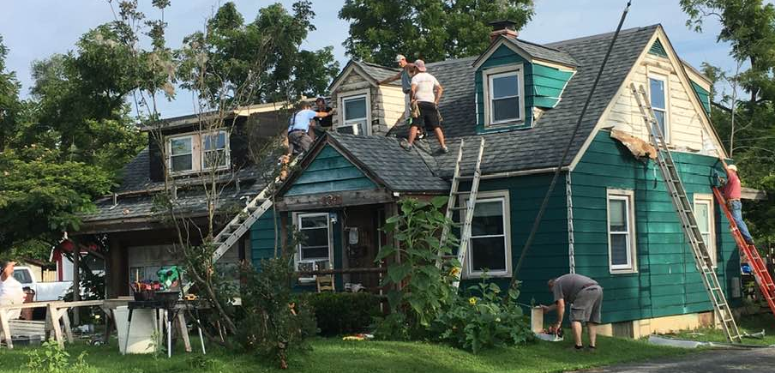
During August, Mennonite Disaster Service began repairing houses in Dayton that were damaged by the 2019 Memorial Day tornadoes. FMC’s Lynn Miller is serving as project director and other FMC members may participate on a daily basis. This is one of the houses being repaired.

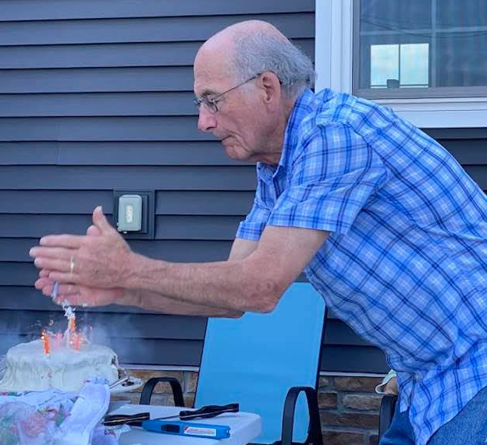
Bob and Linda Suter and their clan observed birthdays and other special occasions outside, distancing by sitting as family groups. To avoid spreading germs, Bob extinguished the candles on his cake by clapping. Equally creative, Linda didn’t let anything prevent her from making her famous chocolate dumplings! She set up outside on Pete and Kim’s patio, plugged into an outlet and made them....as good as ever, according to her family.

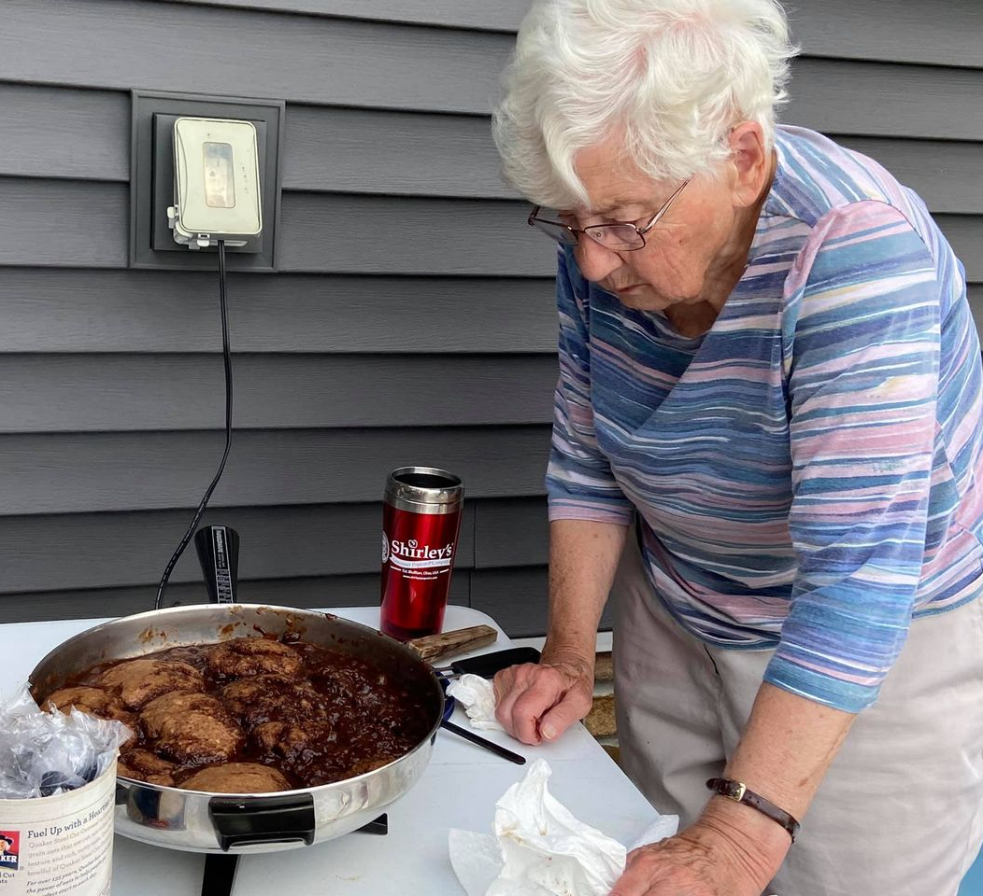

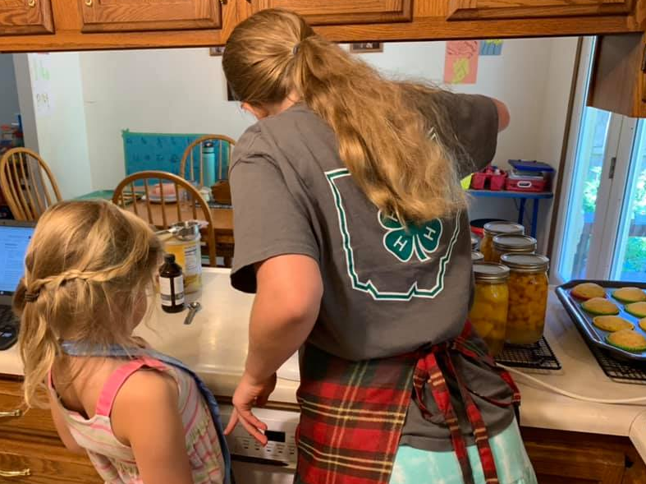
Ellie Hartzler took over teaching duties in the kitchen, teaching her little brother, Micah, how to bake and teaching Anna the art of icing cupcakes.

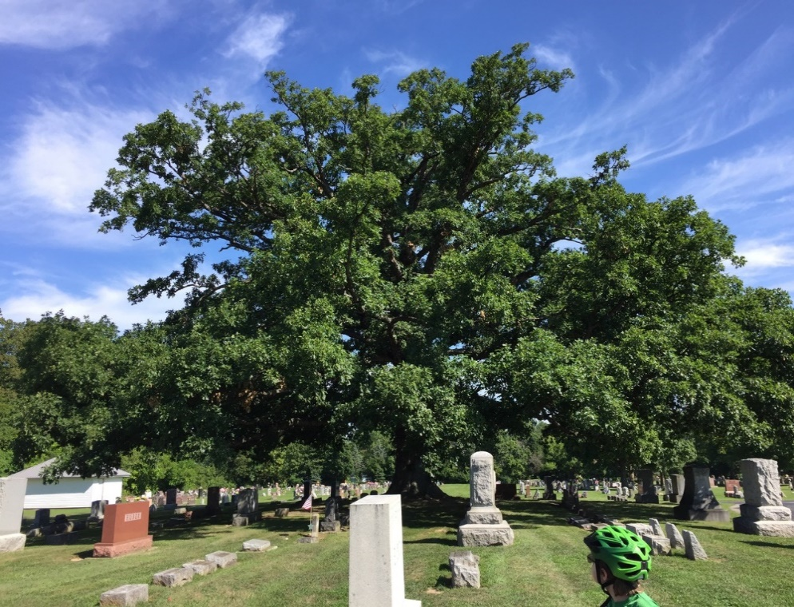
Jorian and Gerald Mast “enjoyed walking in Motter Metropark, exploring the many plants and creatures that thrive there. We usually rode our bikes to the park, stopping first at Maple Grove cemetery to visit the ancient white oak and to remember friends we miss. Then we went across the road to amble through the meadows, taking special delight in the numerous monarch and swallowtail butterflies that were fluttering about.”

Good neighbors, even with masks and socially distanced
Like much of life in pandemic times, uncertainty reigned as the VBS planning team logged into Zoom in April to brainstorm a virtual and safe experience for children in the Bluffton community. Having already had an in-person meeting together in early March - pre-social distancing and masks - to introduce the theme and sort out station assignments, the group now went full-speed into idea generating for adapting Bible story, craft, snack, and games or activity stations, and the overall VBS experience, to a virtual event. The goal was still teaching and learning, with a heavy dose of fun, all rooted in the life of Jesus, but logistics made a sharp left turn:
Theme: Who Is My Neighbor? Learning to Love Like Jesus
How: Combination of short videos, Bingo cards + prizes, and drive-thru pick-ups of craft kits, game supplies, and snack shopping lists.
When: Drive-thru on Thursdays between 6 and 7 pm, June 11 – July 9, videos released weekly. Unable to make it on Thursday nights? Stop in any time to pick up your VBS kits.
Registration: Not required
Offering Project: All Ability Playgrounds of Allen County
Scripture: Mark 12:28-31
Sponsoring Churches: First Mennonite Church, St. Mary's Catholic Church, Emmanuel United Church of Christ, First United Methodist Church, Presbyterian Church, English Evangelical Lutheran Church

Did It Work?
The typical benchmark for measuring the success of the Bluffton Community VBS is outreach based on nightly attendance numbers. Since we didn’t have those figures, I reviewed the numbers we did have - cars in the drive thru, VBS kits picked up, Bingo cards returned, offering collected, YouTube videos viewed - and realized the numbers told a story of mediocre success at best and almost assuredly, not worth the collective time investment. Why wasn’t I feeling bad about our efforts? I realized I had too many stories offering an alternative narrative.
The Number of Cars
There were around 8-15 cars with kids, parents, aunts, and grandparents coming to pick up VBS kits each week. We also attracted people on walks and other people on bicycles. The drive-thru was open from 6-7 p.m. Thursday for five consecutive weeks, staffed with 2-3 volunteers. Thursday, July 2 was the least busy week, perhaps because many people took advantage of the early lead-in to the 4th of July weekend. On a good night, that meant less than 4 cars every 15.
The Alternative Story
As one of those weekly volunteers, and the only volunteer present all 5 weeks, I saw the trends and patterns, and the lack thereof. There were a few repeat customers during the drive-thru hour, but surprisingly, there were new faces every week. Many of the faces belonged to grandparents looking for activities to do with their grandchildren. One grandma who was a repeat drive-thru customer shared this: She and her husband were doing weekly VBS during their weekly childcare with 3 of their grandchildren who live in Elida, while their son and daughter-in-law went to work. One week, the activity station involved charades acting out neighborly acts of kindness. Instead of the children taking center stage with the role playing, grandma and grandpa acted out each scenario together while the children ate lunch and laughed as they tried to guess what kindness their grandparents’ antics depicted.
The Number of VBS Kits
The first challenge was knowing how many kits to prepare. Gauging interest in pandemic-adapted VBS was difficult. Many people expressed interest...
- If it wasn’t just another long video or Zoom.
- If they had time.
- If they were home.
- If they remembered.
We prepared a total of 100 kits for the first week and adjusted the numbers downward to 85 for the remaining four weeks. There were kits left over after every drive-thru, but it was clear that people were picking them up throughout the week and even picking up kits from earlier weeks when they got a late start on VBS, which made determining the exact number of kits taken nearly impossible to track reliably.
The Alternative Story
On several nights, we reined in a mom walking a dog with 3 of her children, all the way across the street to pick up kits and throw some offering into our large, galvanized wash tub. The second time, the mom responded from across the street that they had already picked up the kits from the week before. When we assured them the kits were different each week, they happily crossed to our side. “Might as well!” became our mantra when convincing people to give it all a try.
The Amount of Offering Collected
We collected a total of $344.27 to support construction of the All Ability Playgrounds of Allen County. In addition to our large wash tub of an offering plate, we kept a jug of loose change on the table. When people walked or drove by and didn’t have any offering, we spooned a handful of change into their palms so everyone had a chance to contribute through a noisy offering, whether they were picking up VBS kits or not. I am uncertain how this compares to typical years, but it does ensure a name plate at the Swing Level for the Bluffton Community VBS as one of the sponsors of the playground and neighbors of our friends in our community who will benefit from adaptive playground equipment.

The Alternative Stories
Waving at people and cars with our Mr. Rogers and Daniel Tiger signs was one way volunteers showed hospitality to those passing by. Occasionally, cars headed in the opposite direction of our VBS Drive-thru stopped to see what we were doing. More than once, those drivers pitched in their own donations to support the All-Ability Playgrounds with $20 bills and even one $50 bill.
How Many People Participated
The short answer is we don’t really know. We didn’t require registration due to our unorthodox delivery style. Videos posted on YouTube garnered anywhere from 13-97
Amber Shelly holds up VBS signs featuring Mr. Rogers and Daniel Tiger.
views per video. We distributed many BINGO cards, and 14 cards were returned to collect prizes, all of which were purchased from or donated by local Bluffton businesses. The goal in making a BINGO game out of VBS was twofold: to entice kids to watch all of the VBS videos all the way through, and to support local Bluffton businesses by purchasing BINGO prizes from them, because so many businesses are struggling in these pandemic days. We were trying to live through example of being good neighbors. However, these numbers, in particular, don’t spell overwhelming success at first glance.
The Alternative Stories
After we posted the Week #1 VBS videos for K-5th grade and Preschool, I received an email from a children’s pastor at a Southern Baptist Church in North Carolina. She was searching for VBS videos on YouTube and discovered our Bluffton Community VBS 2020 channel. We had a number of email exchanges and a phone call to discuss how we were approaching VBS during the pandemic. I even shared our BINGO card design file with the pastor as they explored possibilities for bringing VBS to their children. What an unexpected connection this was!
In addition, the businesses I spoke with prior to the start of VBS seemed surprised and more than a little welcoming to be sponsors when they realized we weren’t looking for anything free. In fact, at the end of July when it was time to purchase and collect the BINGO prizes, several of the businesses offered their prizes for free or at a reduced cost. Talk about being good neighbors!
After VBS in 2020, virtual or not, I’m convinced outreach is best measured in stories rather than numbers. The gifts we receive when we live according to the values Jesus Christ extolled in his own story-telling and preaching and his examples of living and associating with and loving all people are matters not intended to be quantified. In fact, God and God’s love exceeds anything we can know. Was the Bluffton Community VBS 2020 a success? I believe so, and if pandemic times present themselves again next year, the planning team can count me in.
Which commandment is the first of all? Jesus answered, The first is Hear, O Israel: the Lord our God, the Lord is one; you shall love the Lord your God with all your heart, and with all your soul, and with all your mind, and with all your strength. The second is this, You shall love your neighbor as yourself. There is no other commandment greater than these. Mark 12:28b-31

