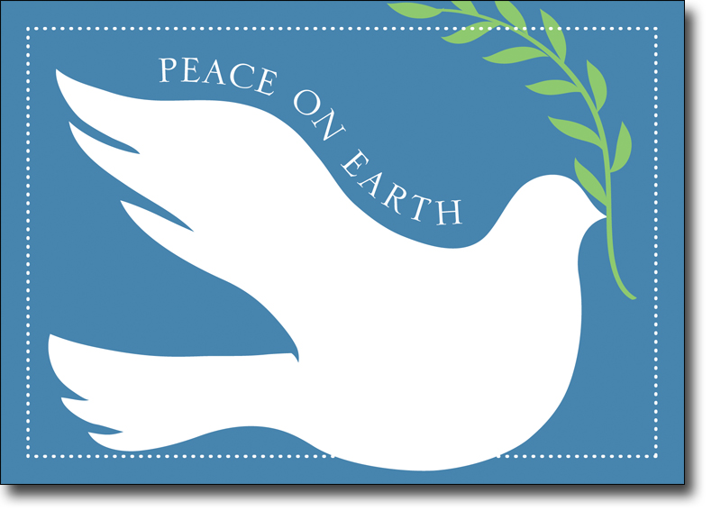

*May the peace and joy of the holiday season be with you throughout the coming year. -- First Mennonite Church*